**EXERCISE 1: CREATE A SPRING WEB PROJECT USING MAVEN**

**SPRINGLEARNAPPLICATION.JAVA**

**package** com.cognizant.spring_learn;

**import** org.springframework.boot.SpringApplication;

**import** org.springframework.boot.autoconfigure.SpringBootApplication;

**import** org.slf4j.Logger;

**import** org.slf4j.LoggerFactory;

**public** **class** SpringLearnApplication {

**private** **static** **final** Logger ***LOGGER*** = LoggerFactory.*getLogger*(SpringLearnApplication.**class**);

**public** **static** **void** main(String[] args) {

***LOGGER***.info("START");

SpringApplication.*run*(SpringLearnApplication.**class**, args);

***LOGGER***.info("END");

}

}

**POM.XML**

<dependencies>

<dependency>

<groupId>org.springframework.boot</groupId>

<artifactId>spring-boot-starter-web</artifactId>

</dependency>

<dependency>

<groupId>org.springframework.boot</groupId>

<artifactId>spring-boot-devtools</artifactId>

<scope>runtime</scope>

</dependency>

<dependency>

<groupId>org.springframework.boot</groupId>

<artifactId>spring-boot-starter-test</artifactId>

<scope>test</scope>

</dependency>

</dependencies>

**OUTPUT**

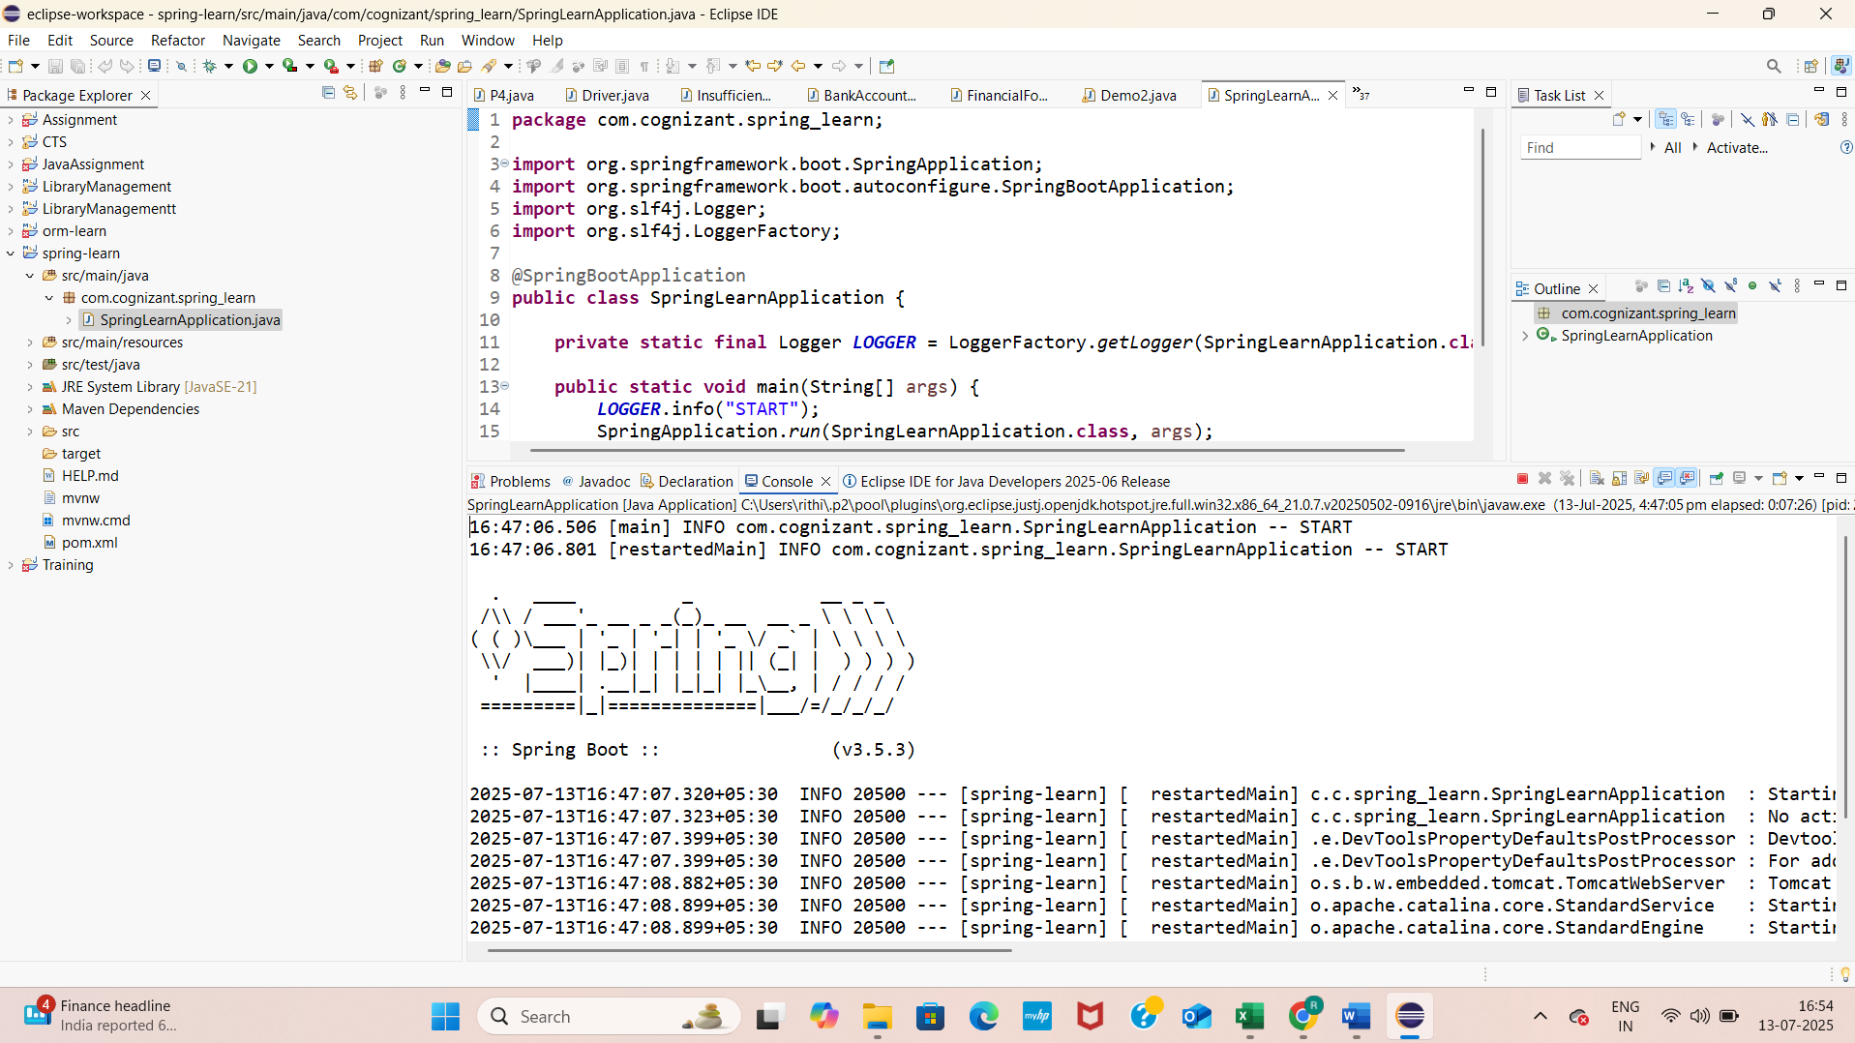

**EXERCISE 4: SPRING CORE – LOAD COUNTRY FROM SPRING CONFIGURATION XML** 

**COUNTRY.JAVA**

package com.cognizant.springlearn;

import org.slf4j.Logger;

import org.slf4j.LoggerFactory;

public class Country {

private static final Logger LOGGER = LoggerFactory.getLogger(Country.class);

private String code;

private String name;

public Country() {

LOGGER.debug("Inside Country Constructor.");

}

public String getCode() {

LOGGER.debug("Inside getCode()");

return code;

}

public void setCode(String code) {

LOGGER.debug("Inside setCode()");

this.code = code;

}

public String getName() {

LOGGER.debug("Inside getName()");

return name;

}

public void setName(String name) {

LOGGER.debug("Inside setName()");

this.name = name;

}

public String toString() {

return "Country [code=" + code + ", name=" + name + "]";

}

}

**COUNTRY.XML**

<?xml version="1.0" encoding="UTF-8"?>

<beans xmlns="http://www.springframework.org/schema/beans"

xmlns:xsi="http://www.w3.org/2001/XMLSchema-instance"

xsi:schemaLocation="

http://www.springframework.org/schema/beans

http://www.springframework.org/schema/beans/spring-beans.xsd">

<bean id="country" class="com.cognizant.springlearn.Country">

<property name="code" value="IN"/>

<property name="name" value="India"/>

</bean>

</beans>

**SPRINGLEARNAPPLICATION.JAVA**

package com.cognizant.springlearn;

import org.slf4j.Logger;

import org.slf4j.LoggerFactory;

import org.springframework.context.ApplicationContext;

import org.springframework.context.support.ClassPathXmlApplicationContext;

public class SpringLearnApplication {

private static final Logger LOGGER = LoggerFactory.getLogger(SpringLearnApplication.class);

public static void main(String[] args) {

displayCountry();

}

public static void displayCountry() {

ApplicationContext context = new ClassPathXmlApplicationContext("country.xml");

Country country = context.getBean("country", Country.class);

LOGGER.debug("Country : {}", country.toString());

}

}

**POM.XML**

<dependency>

<groupId>org.slf4j</groupId>

<artifactId>slf4j-api</artifactId>

<version>2.0.13</version>

</dependency>

<dependency>

<groupId>org.slf4j</groupId>

<artifactId>slf4j-simple</artifactId>

<version>2.0.13</version>

</dependency>

**OUTPUT**

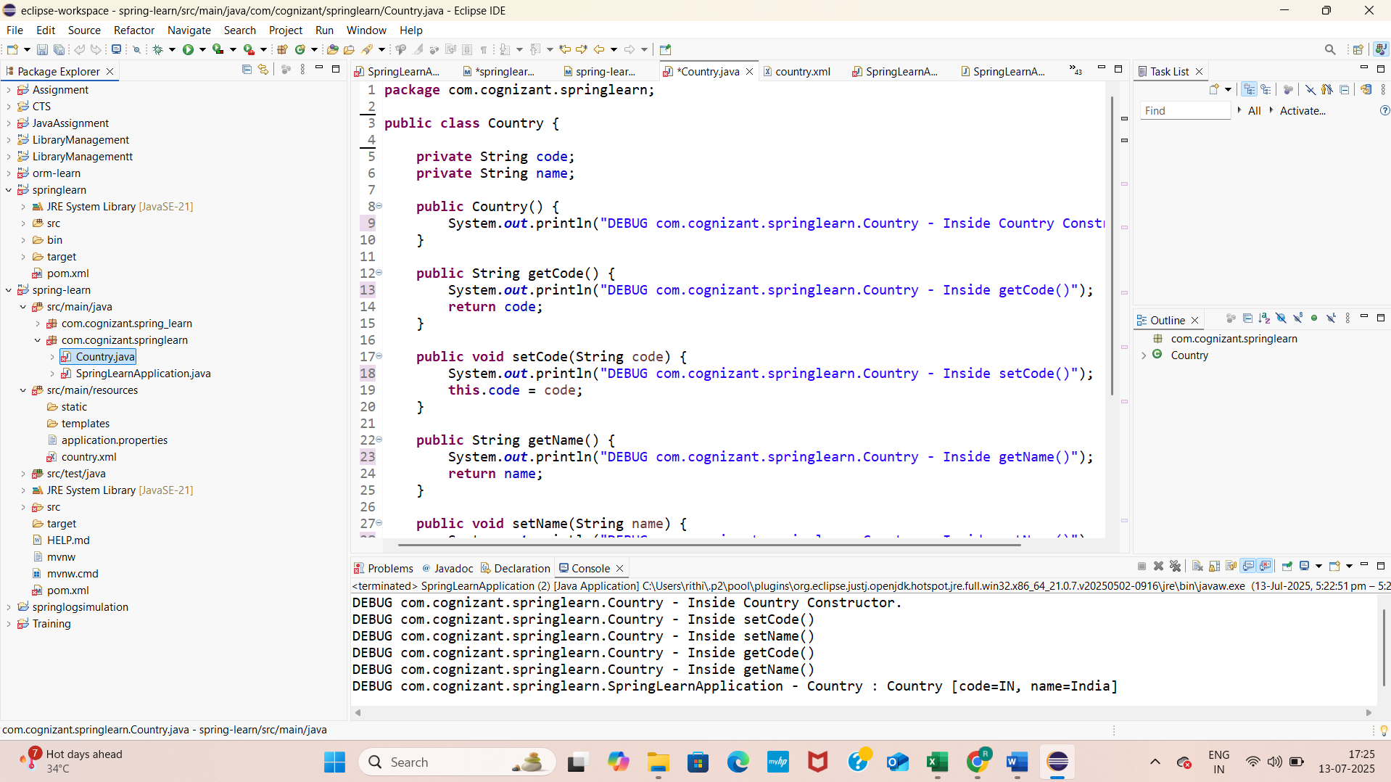

**EXERCISE: HELLO WORLD RESTFUL WEB SERVICE**

**HELLOCONTROLLER.JAVA**

package com.cognizant.springlearn.controller;

import org.slf4j.Logger;

import org.slf4j.LoggerFactory;

import org.springframework.web.bind.annotation.GetMapping;

import org.springframework.web.bind.annotation.RestController;

@RestController

public class HelloController {

private static final Logger LOGGER = LoggerFactory.getLogger(HelloController.class);

@GetMapping("/hello")

public String sayHello() {

LOGGER.info("START sayHello()");

String message = "Hello World!!";

LOGGER.info("END sayHello()");

return message;

}

}

**STRINGLEARNAPPLICATION.JAVA**

package com.cognizant.springlearn;

import org.springframework.boot.SpringApplication;

import org.springframework.boot.autoconfigure.SpringBootApplication;

@SpringBootApplication

public class SpringLearnApplication {

public static void main(String[] args) {

SpringApplication.run(SpringLearnApplication.class, args);

}

}

**OUTPUT**

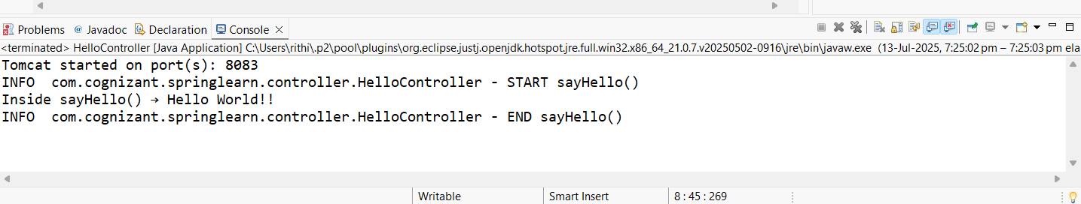

**EXERCISE: REST - COUNTRY WEB SERVICE**

**COUNTRY.JAVA**

package com.cognizant.spring-learn;

public class Country {

private String code;

private String name;

public String getCode() {

return code;

}

public void setCode(String code) {

this.code = code;

}

public String getName() {

return name;

}

public void setName(String name) {

this.name = name;

}

}

**SPRING-CONFIG.XML**

<?xml version="1.0" encoding="UTF-8"?>

<beans xmlns="http://www.springframework.org/schema/beans"

xmlns:xsi="http://www.w3.org/2001/XMLSchema-instance"

xsi:schemaLocation="

http://www.springframework.org/schema/beans

http://www.springframework.org/schema/beans/spring-beans.xsd">

<bean id="in" class="com.cognizant.spring-learn.Country">

<property name="code" value="IN" />

<property name="name" value="India" />

</bean>

</beans>

**COUNTRYCONTROLLER.JAVA**

package com.cognizant.spring-learn.controller;

import com.cognizant.spring-learn.Country;

import org.springframework.beans.factory.xml.XmlBeanFactory;

import org.springframework.core.io.ClassPathResource;

import org.springframework.web.bind.annotation.RequestMapping;

import org.springframework.web.bind.annotation.RestController;

public class CountryController {

public Country getCountryIndia() {

XmlBeanFactory factory = new XmlBeanFactory(new ClassPathResource("spring-config.xml"));

Country country = (Country) factory.getBean("in");

return country;

}

}

**POM.XML**

<dependencies>

<dependency>

<groupId>org.springframework.boot</groupId>

<artifactId>spring-boot-starter-web</artifactId>

</dependency>

</dependencies>

**OUTPUT**

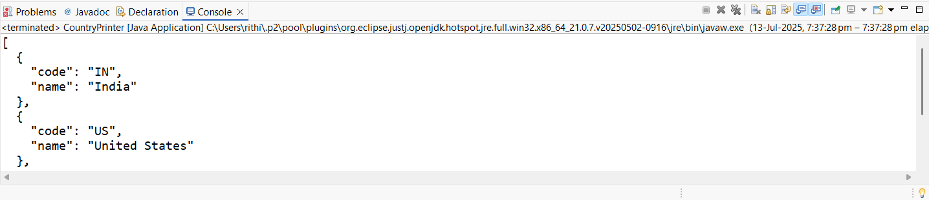

**EXERCISE: REST - GET COUNTRY BASED ON COUNTRY CODE**

**COUNTRY.JAVA**

package com.cognizant.spring-learn;

public class Country {

private String code;

private String name;

public Country() {}

public Country(String code, String name) {

this.code = code;

this.name = name;

}

public String getCode() {

return code;

}

public void setCode(String code) {

this.code = code;

}

public String getName() {

return name;

}

public void setName(String name) {

this.name = name;

}

}

**COUNTRY.XML**

<?xml version="1.0" encoding="UTF-8"?>

<countries>

<country>

<code>IN</code>

<name>India</name>

</country>

<country>

<code>US</code>

<name>United States</name>

</country>

<country>

<code>AU</code>

<name>Australia</name>

</country>

</countries>

**COUNTRYSERVICE.JAVA**

package com.cognizant.spring-learn.service;

import com.cognizant.spring-learn.Country;

import org.w3c.dom.*;

import javax.xml.parsers.*;

import java.io.InputStream;

import java.util.*;

import java.util.stream.Collectors;

import org.springframework.stereotype.Service;

public class CountryService {

public Country getCountry(String code) {

List<Country> countryList = loadCountriesFromXML();

Optional<Country> result = countryList.stream()

.filter(c -> c.getCode().equalsIgnoreCase(code))

.findFirst();

return result.orElse(null);

}

private List<Country> loadCountriesFromXML() {

List<Country> countryList = new ArrayList<>();

try {

InputStream is = getClass().getClassLoader().getResourceAsStream("country.xml");

if (is == null) {

throw new RuntimeException("country.xml not found in resources");

}

DocumentBuilderFactory factory = DocumentBuilderFactory.newInstance();

DocumentBuilder builder = factory.newDocumentBuilder();

Document doc = builder.parse(is);

NodeList nodeList = doc.getElementsByTagName("country");

for (int i = 0; i < nodeList.getLength(); i++) {

Element element = (Element) nodeList.item(i);

String code = element.getElementsByTagName("code").item(0).getTextContent();

String name = element.getElementsByTagName("name").item(0).getTextContent();

countryList.add(new Country(code, name));

}

} catch (Exception e) {

e.printStackTrace();

}

return countryList;

}

}

**COUNTRYCONTROLLER.JAVA**

package com.cognizant.spring-learn.controller;

import com.cognizant.spring-learn.Country;

import com.cognizant.spring-learn.service.CountryService;

import org.springframework.beans.factory.annotation.Autowired;

import org.springframework.web.bind.annotation.*;

public class CountryController {

private CountryService countryService;

public Country getCountry(@PathVariable String code) {

return countryService.getCountry(code);

}

}

**SPRINGLEARNAPPLICATION.JAVA**

package com.cognizant.spring-learn;

import org.springframework.boot.SpringApplication;

import org.springframework.boot.autoconfigure.SpringBootApplication;

public class SpringLearnApplication {

public static void main(String[] args) {

SpringApplication.run(SpringLearnApplication.class, args);

}

}

**POM.XML**

<dependencies>

<dependency>

<groupId>org.springframework.boot</groupId>

<artifactId>spring-boot-starter-web</artifactId>

</dependency>

</dependencies>

**OUTPUT**

